CO226-Apr2025 : Database Systems
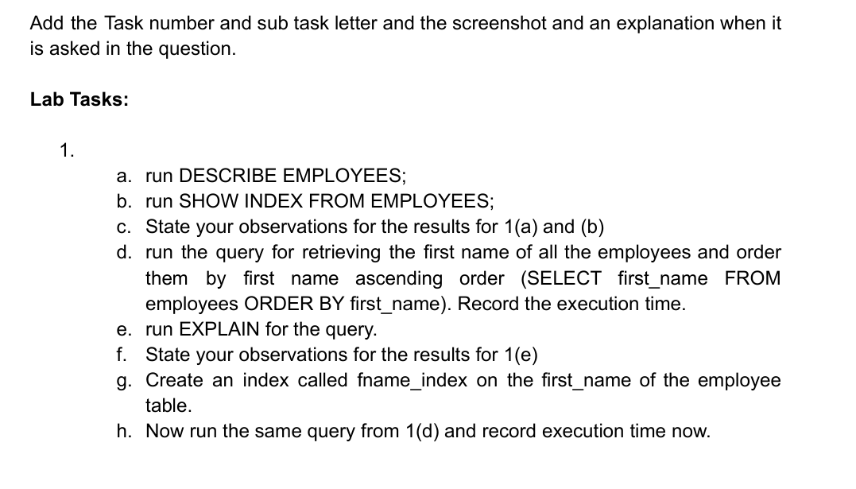
Lab 08
E/21/245
MADHUSHAN S.K.A.K.

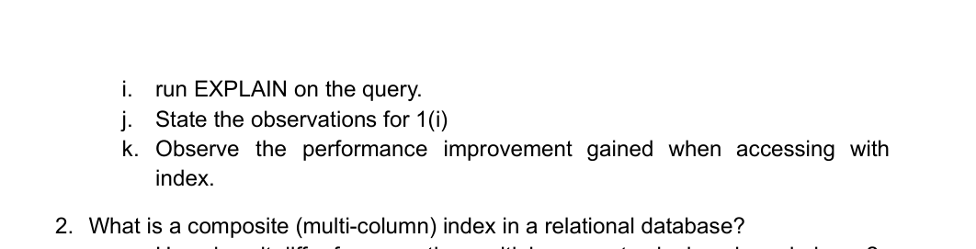

1.
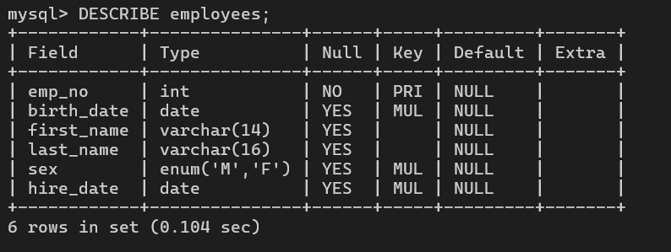
a.

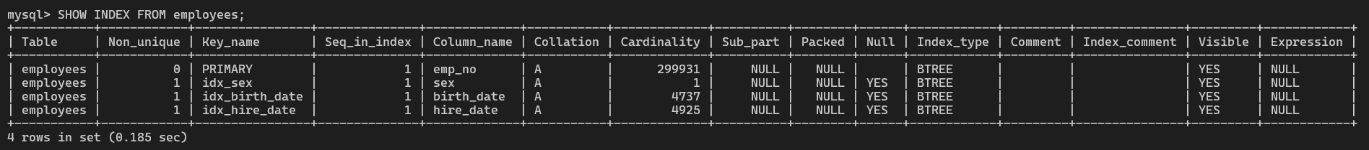
b.

c.
1(a) – DESCRIBE employees
- The employees table contains 6 columns.
- emp_no is the primary key.
- birth_date, sex, and hire_date are marked as indexed (MUL).
- first_name and last_name are not indexed yet, which means queries using them (e.g., sorting, searching) may not be optimized.
1(b) – SHOW INDEX FROM employees :
- Total of 4 indexes exist:
  - PRIMARY index on emp_no – ensures uniqueness.
  - idx_sex on sex – helpful for filtering by gender.
  - idx_birth_date on birth_date – good for age-related queries.
  - idx_hire_date on hire_date – useful for service-duration filtering.
- No index exists on first_name or last_name, so:
  - Queries like ORDER BY first_name or WHERE first_name = ... will result in full table scans, which are slower.
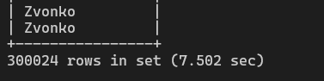
d.

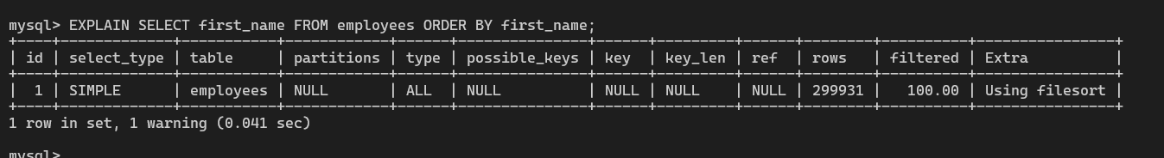
e.

f.
Field | Value | Meaning
type | ALL | Full table scan (least efficient) — MySQL reads all 299,931 rows.
key | NULL | No index is being used.
rows | 299931 | The optimizer estimates that all rows must be read.
Extra | Using filesort | MySQL performs a temporary sort operation, which is slow for large tables.

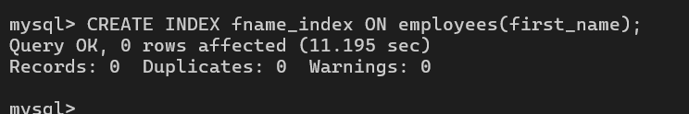
g.

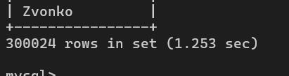
h.

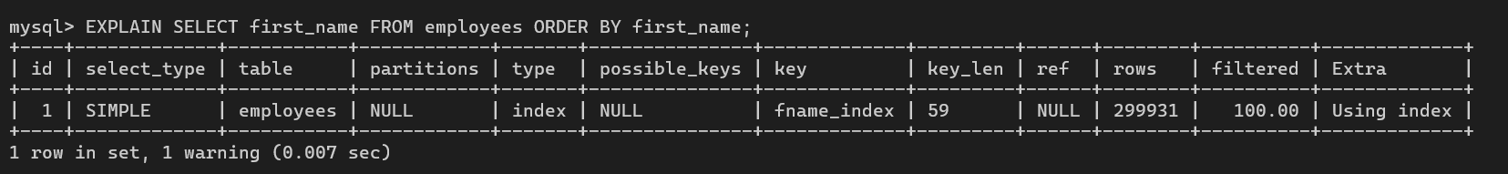
i.

j.
Field | Value | Meaning
type | index | MySQL is scanning the index instead of the full table — this is much faster than ALL.
key | fname_index | The query is now using the newly created index on first_name.
Extra | Using index | The query is covered by the index — no need to read full table rows.
rows | 299931 | Same number of rows read, but from index structure (B-tree), which is more efficient.
key_len | 59 | Represents the length of the index key used (includes overhead).

k.
Before creating fname_index:
The query used:
  - type = ALL → Full table scan
  - Extra = Using filesort → Slow manual sorting by MySQL
Execution Time: can be much higher depending on system size/load

After creating fname_index:
The query used:
  - type = index → Efficient index scan
  - key = fname_index → Index on first_name used
  - Extra = Using index → No need to access the table; only index is used
Execution Time: very speed

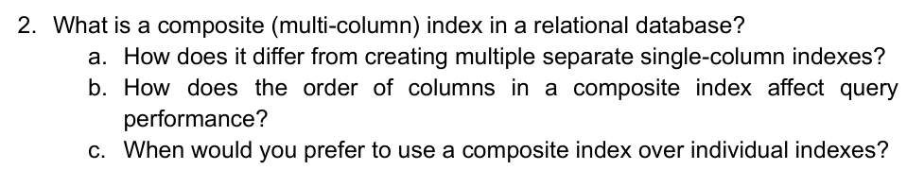
2.

A composite index (also called a multi-column index) is an index created on two or more columns of a table.It allows the database to efficiently handle queries that involve filtering, sorting, or joining based on multiple columns together.
(a) Difference from multiple single-column indexes
Composite Index ((A, B)) | Two Separate Indexes (A, B)
One index on both columns | Two independent indexes
Efficient for queries using both A and B together | Works well only if query filters A or B individually
Can optimize sorting or range queries on both columns | May require combining results from separate indexes (less efficient)
Uses index prefix (e.g., A → A+B) | No combined optimization possible

(b)The order matters a lot in composite indexes because of the leftmost prefix rule:
A composite index on (A, B) can be used for:
  - Queries on A
  - Queries on A AND B
But cannot be fully used for queries only on B

(c) Use a composite index when:
- queries often filter/sort using multiple columns together.
- We want to avoid filesort when using ORDER BY col1, col2.
- we frequently join or group by the same set of columns.
- we want to speed up range scans involving multiple fields.
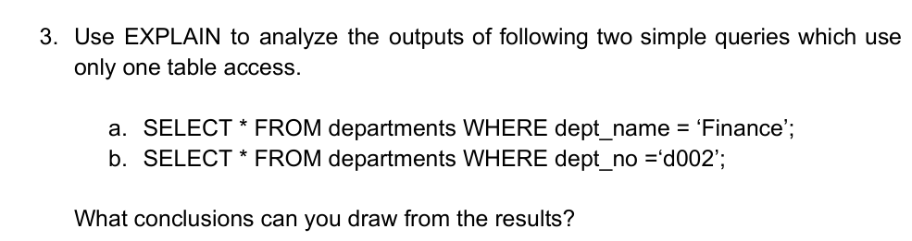

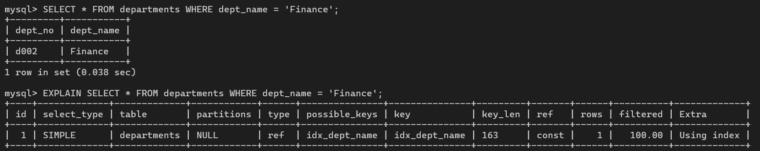
a.

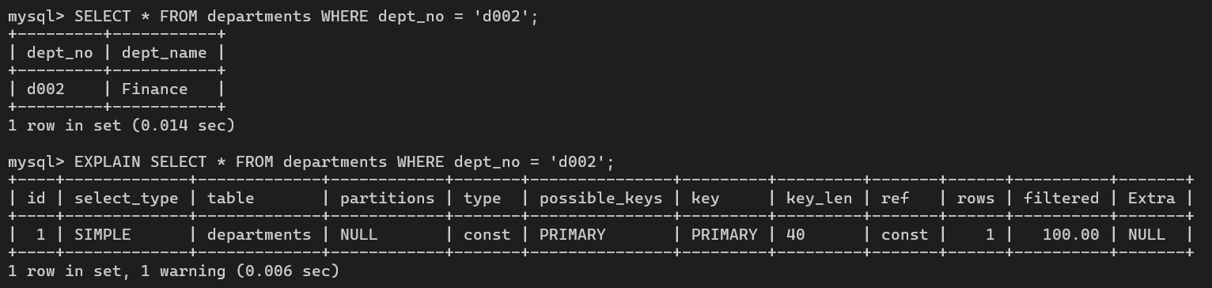
b.

a. Query 1 Execution and 1 row returned
- Execution time: 0.038 sec
EXPLAIN Output for query one Observation:
The query uses the index idx_dept_name, with type = ref, which is efficient. Since dept_name has an index, MySQL doesn’t scan the whole table — it uses the index to locate matching rows directly.
b. Query 2 Execution and 1 row returned
- Execution time: 0.014 sec
EXPLAIN Output for Query 2 Observation:
This query uses the primary key (dept_no), with type = const, which is the most efficient type of access. MySQL recognizes it's using a unique key with a constant value.
Conclusion
In here Query (a) is efficient because of the index on dept_name (idx_dept_name), using a ref type lookup.Query (b) is even more efficient, using the primary key with type = const, which is the best possible performance for a single-row lookup. So we see that Primary keys offer the fastest lookups. Indexing non-primary columns (like dept_name) can still yield fast performance, but slightly less optimal than a primary key.
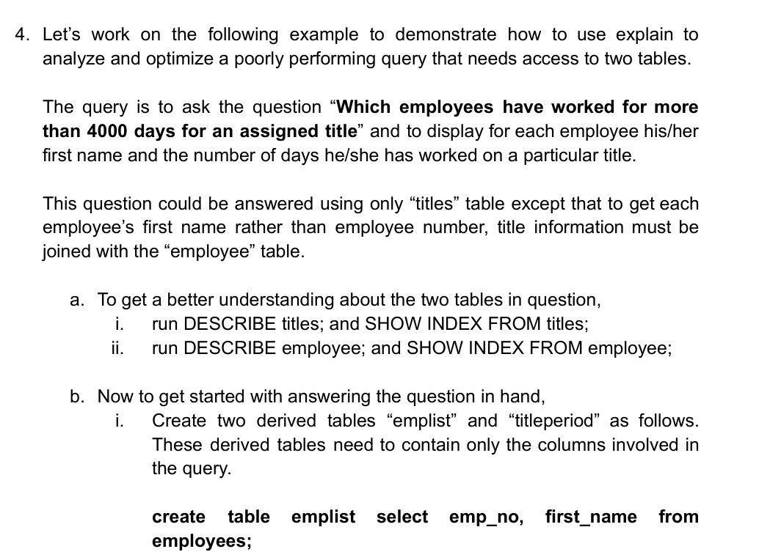

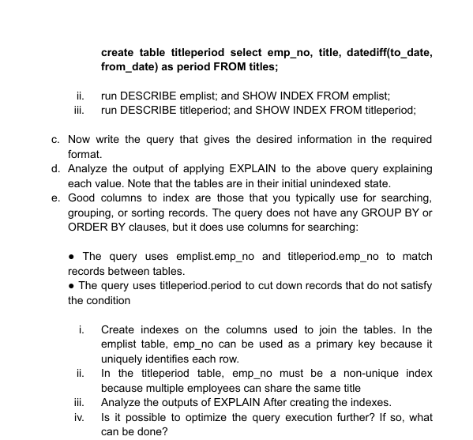

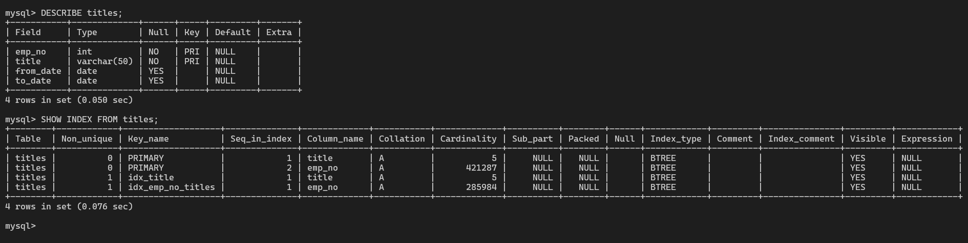
- i.

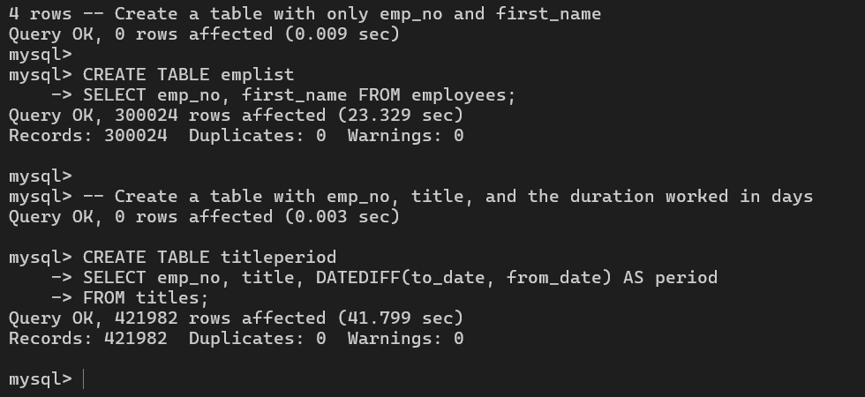
- i.

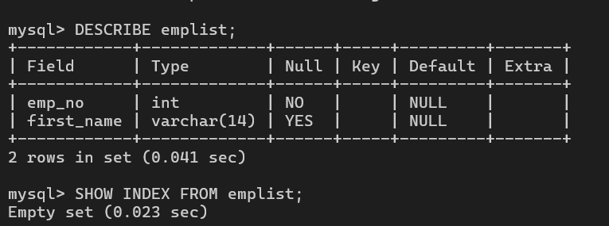
ii.

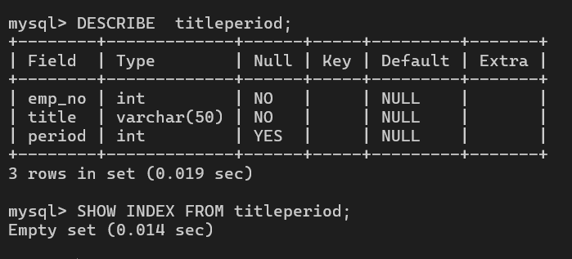
iii.

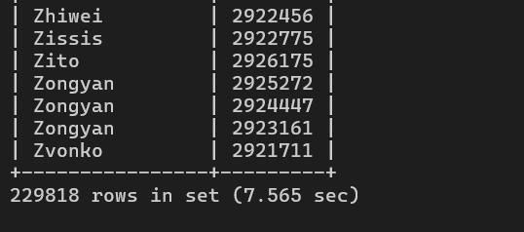
c.

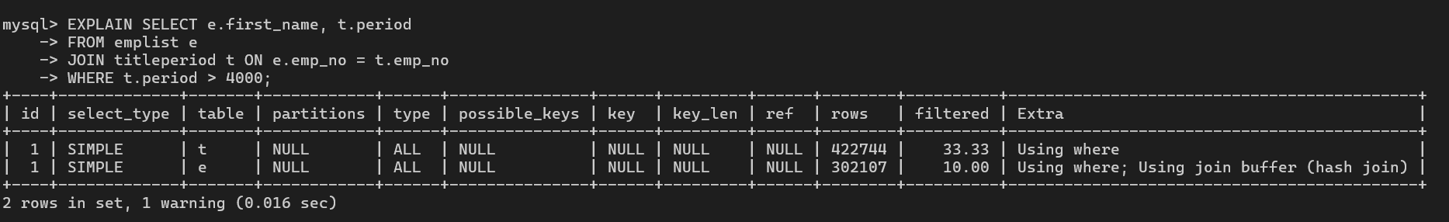
d.

Table | Access Type | Possible Keys | Key Used | Rows | Extra
t (titleperiod) | ALL | NULL | NULL | ~422,744 | Using where
e (emplist) | ALL | NULL | NULL | ~302,107 | Using where; Using join buffer (hash join)

- Access Type ALL: Both tables are being fully scanned this is the least efficient join method in SQL.
- No Index Used: No possible_keys or key values means the optimizer didn’t find any indexes to use for filtering or joining.
- Rows Scanned: MySQL expects to scan hundreds of thousands of rows from both tables.
- Join Method: It uses a join buffer with hash join, which is slower than indexed lookups.
- Filtering: The condition t.period > 4000 is being applied after the full scan, making it expensive.

e. i.,ii.
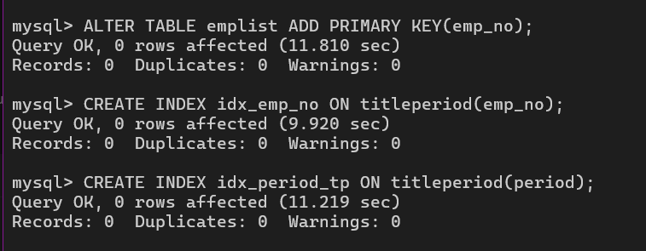

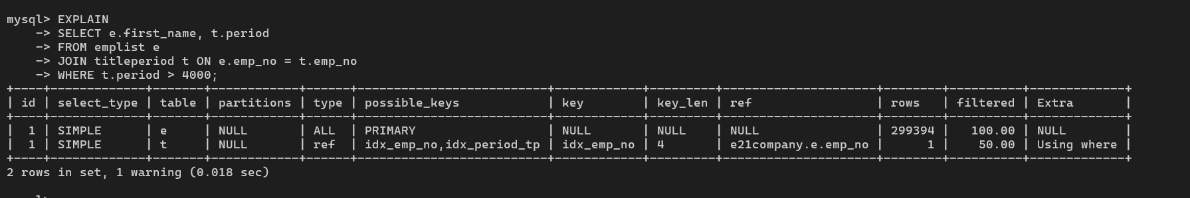
iii.

The query shows two tables: emplist (alias e) and titleperiod (alias t).
For emplist:
  - type = ALL means a full table scan is performed on emplist.
  - key = NULL means no index was used for this table.
  - It estimates scanning about 299,394 rows.
For titleperiod:
  - type = ref means a non-unique index lookup was used.
  - key = idx_emp_no shows the index on emp_no was used for the join.
  - It uses the e.emp_no value to find matching rows in titleperiod.
  - It estimates only about 1 row will be checked per emplist row.
  - The Using where in Extra means the WHERE condition (t.period > 4000) is applied after fetching rows.
iv. we can use composite index like this:
$$CREATE INDEX idx_tp_composite ON titleperiod(emp_no, period);$$
This helps MySQL avoid reading the full row when both columns are used in the query.
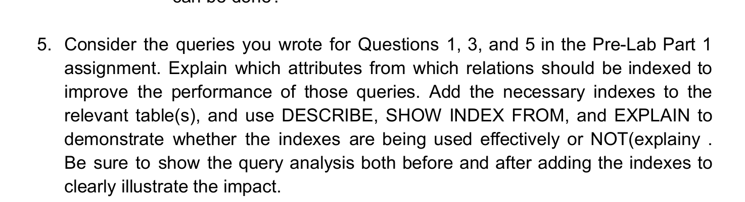

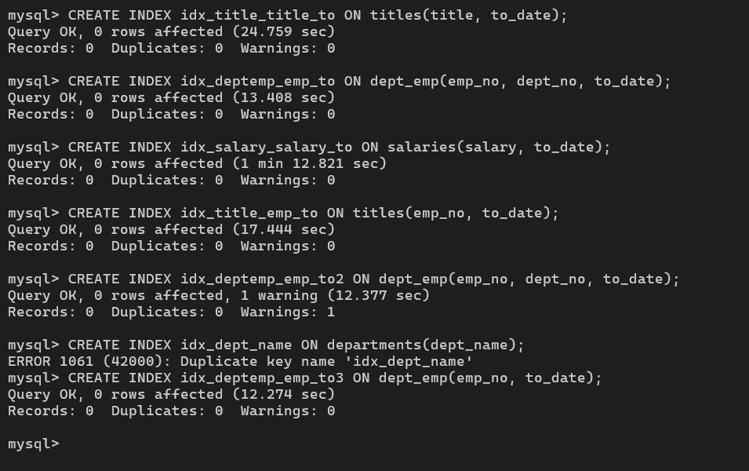
creating the indexes for quearies

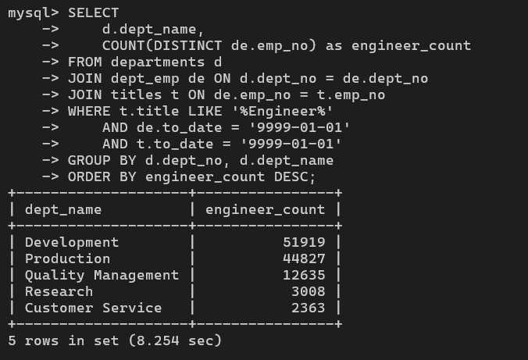
Rerun to lookup the effectiveness
Rerun optimized Query 1:

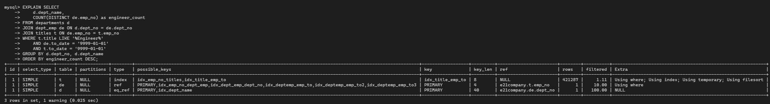
with explain

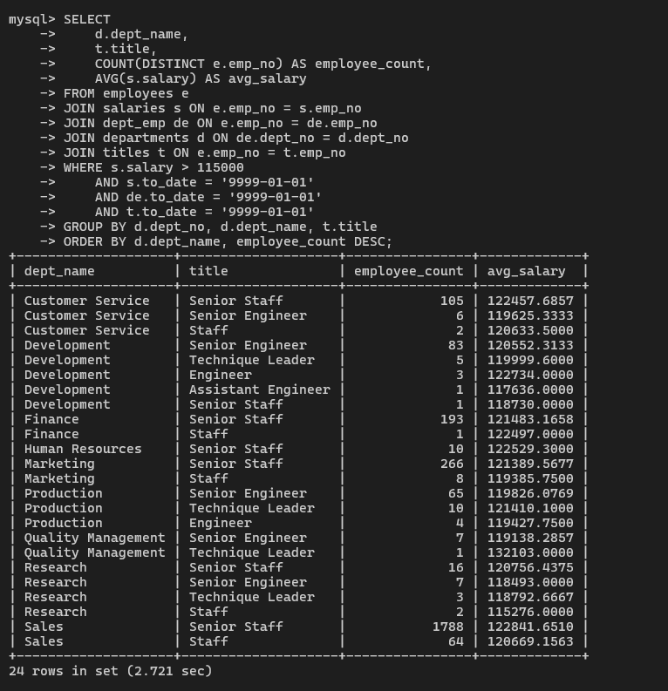
Rerun optimized Query 3:

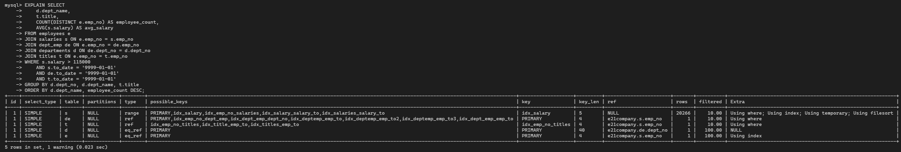
explain for querie 3:-

Rerun optimized Query 5:
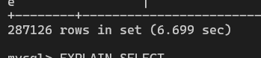

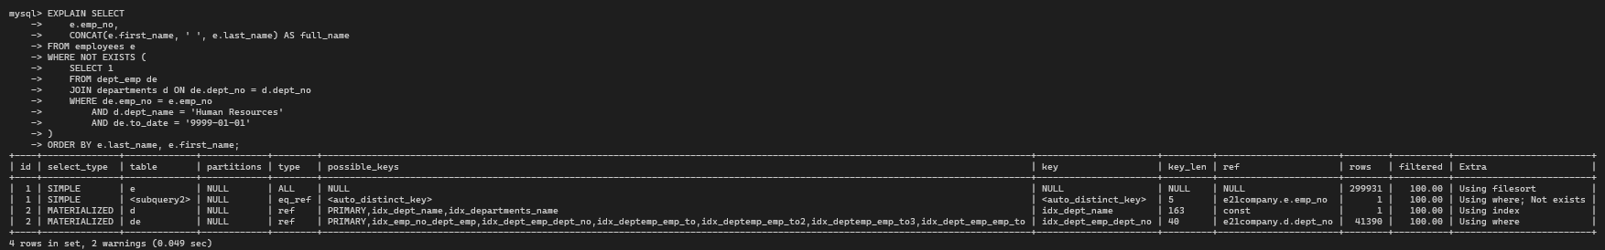
Explain the query 5


If a relation (table) is mostly used for insert/update/delete operations, having an index can slow down these operations.
Impact of Index on INSERT/UPDATE/DELETE:
  - INSERT: The database not only inserts the new row but also has to update all relevant indexes (e.g., adding the new value into a B-tree).
  - UPDATE: If the updated column is indexed, the index must be modified or restructured, which adds overhead.
  - DELETE: When deleting a row, the corresponding index entries must also be removed, which takes extra time.

